Disclaimer : Forecasts and predictions tell you more about the forecaster than about the future :-)

- On Sep 20, 2021, Bob Moriarty stated
“Think of the resource market in 2008 that topped in March and kept diving lower and lower into October and beyond. I did some research into the DSI of gold and silver back then. Gold hit a low of 11 and silver a DSI of 5 on September 11th of 2008. Remarkably gold and silver both hit 10 on September 16th of 2021. That should be a tradable low.”
Moriarty relies on the DSI reporting services of Jake Bernstein.
https://netpressinc.com/store/product-category/dsi-dsie/

- On Sept 23, 2021 Plunger stated
“I could see this happening where we get a bottom over the next 2-3 weeks and then rallying out for the rest of the year then retesting or going to new lows next year.”

- On Sept 28, 2021 Michael Oliver (being interviewed by Jay Taylor) stated
That according to his momentum analysis, gold needs to stay above $1709 mark by the end of Q 3 (Sept 30th) in order to enter into a bullish upward move. I have attached the interview below for anyone wanting to listen. It starts at 7:45 to 15:30 and he mentions $1709 around 15:00. He feels that if that number holds, the gold market will turn around and gain traction on its next ascent to $1800.
https://www.voiceamerica.com/episode/133512/the-money-tree-open-borders-and-other-aoc-fantasies

- On Sept 30, 2021 Otavio (Tavi) Costa posted a chart that shows Silver outflows from Silver miners ETF for the last 12 years. We are at all-time highs … in fact at 3x what we saw during March 2020 pandemic high.

- On Oct 1, 2021 The AUA Gold Miners Bullish Percent Index is hovering around the 20% mark.
At the 20% area, it indicates that it is oversold… but can drop further in a week or two.
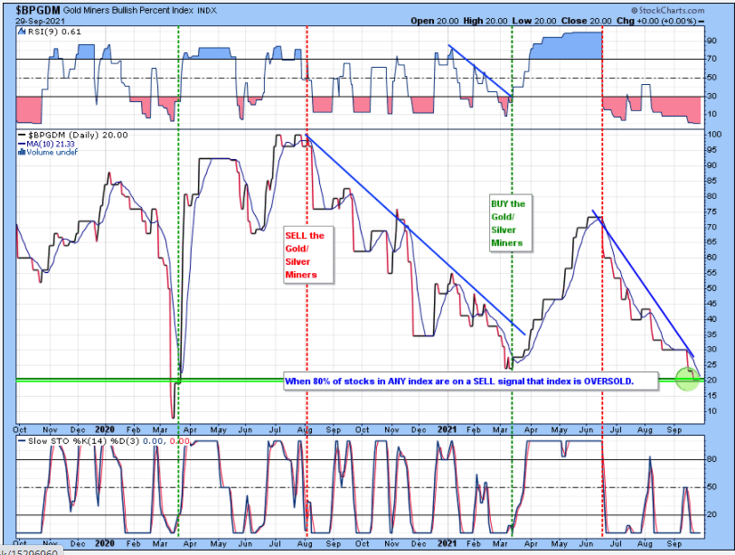
https://stockcharts.com/public/1906477/chartbook/236613197

Before the final drop is in, Gold could drop to $1680 and Silver to $19.
Charts below from https://jessescrossroadscafe.blogspot.com/

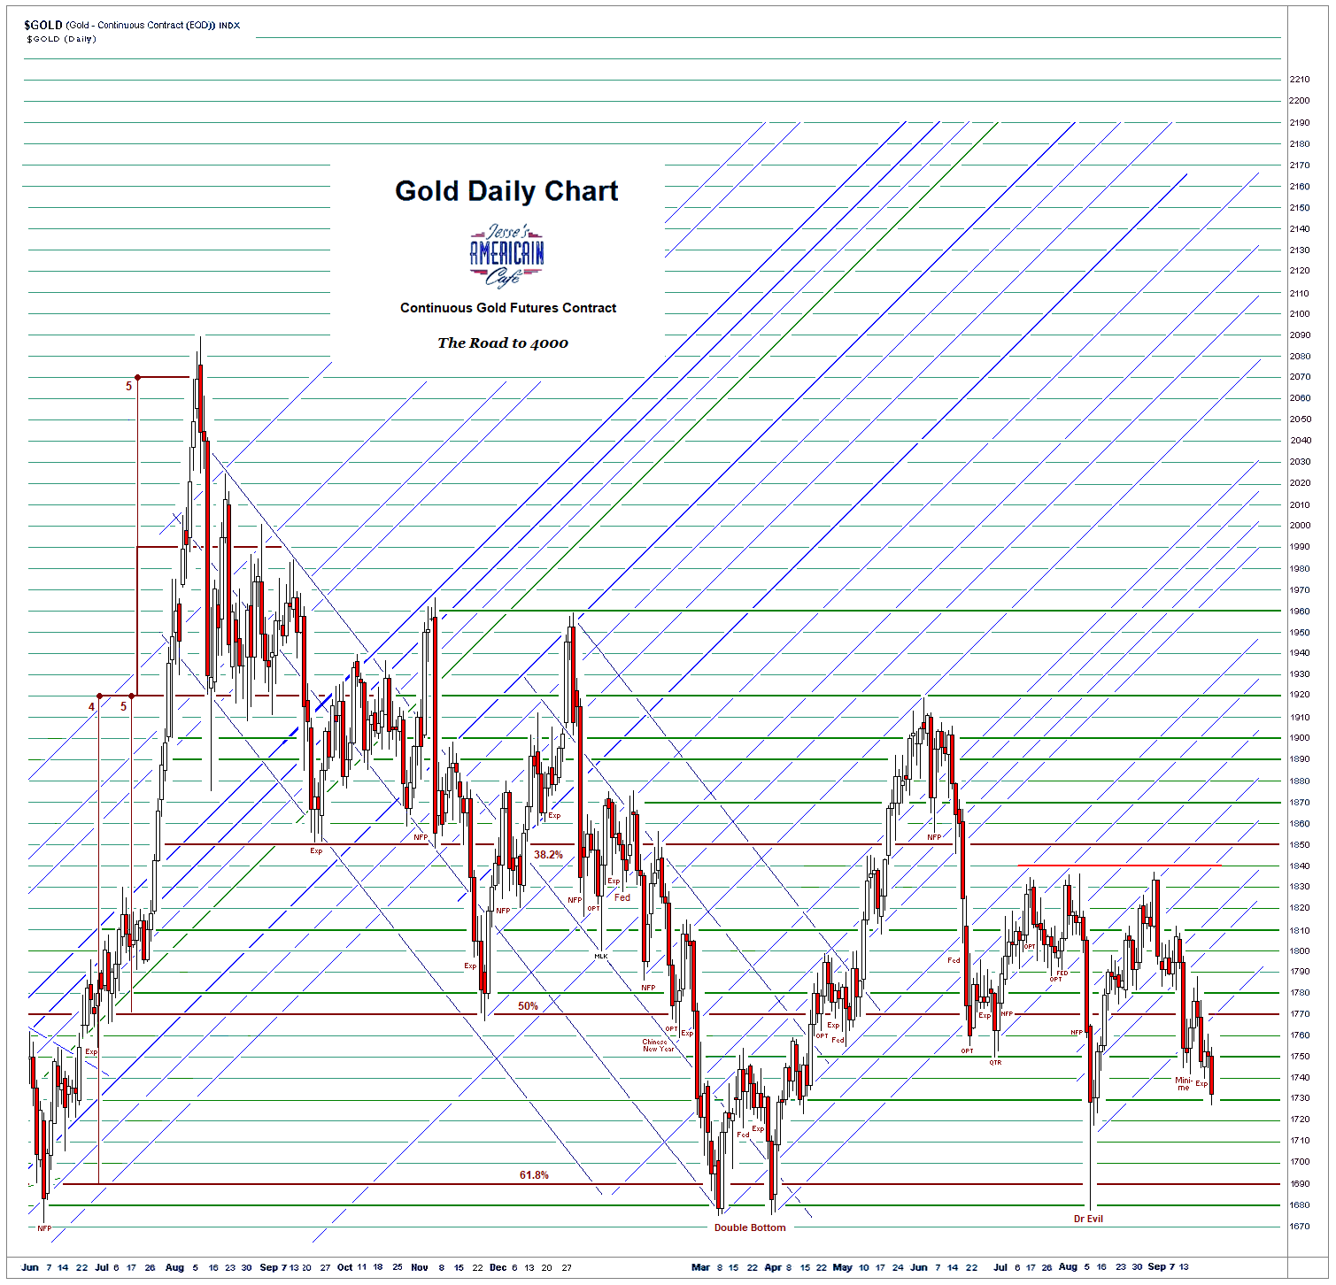

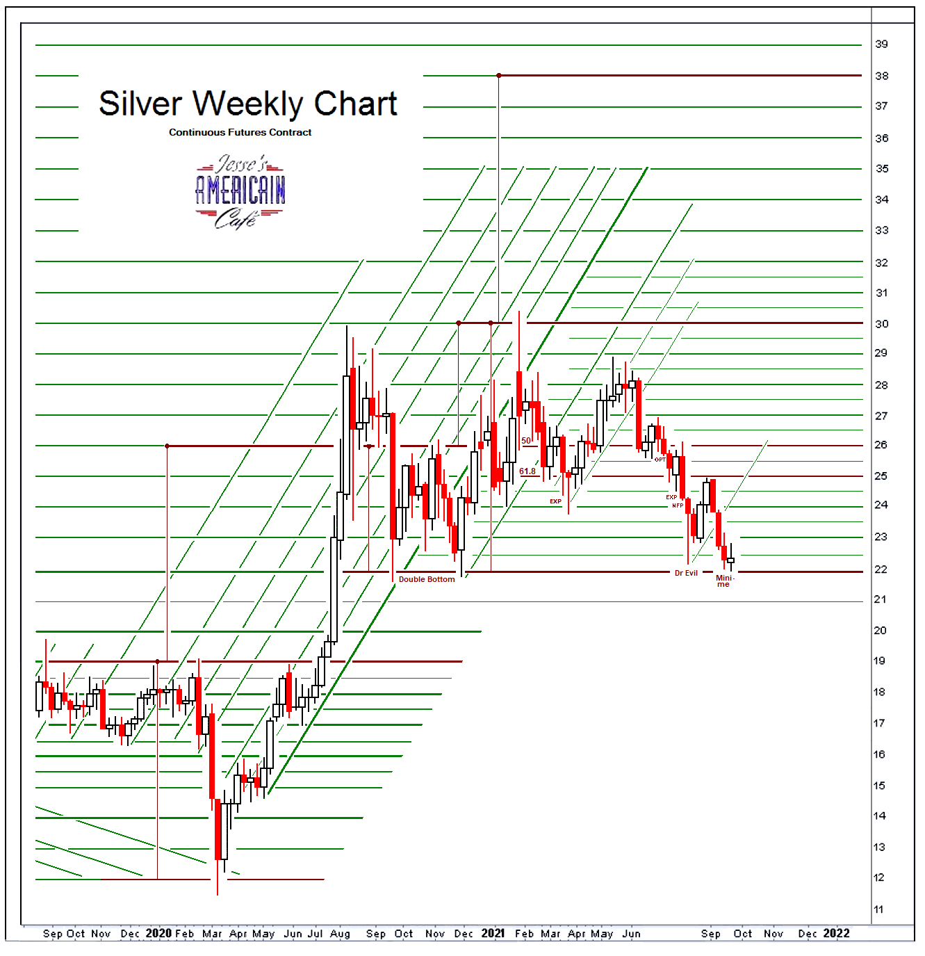

I don’t care to admit how many times I have been disappointed with non-eventful rallies in AG and AU.
My feeling is that a descent run up is likely in the making this time around.
Timing could be as Plunger suggested – in early to mid-October 2021.

